Zoe Logan

ROLES

Avenue Q

A Midsummer Night’s Dream

Carrie The Musical

Legally Blonde

Dial M for Murder

The One Act Play That Goes Wrong

Little Women

Jekyll & Hyde The Musical

Jekyll & Hyde The Musical
Gary Coleman

Hippolyta/ Titania

Miss Gardner

Serena

Margot

Sandra

Marmee

Nellie

Ensemble
Catawba College Catawba College

Catawba College

Porter Ridge High

Porter Ridge High

Porter Ridge High

Porter Ridge High

Catawba College

Lee Street Theatre


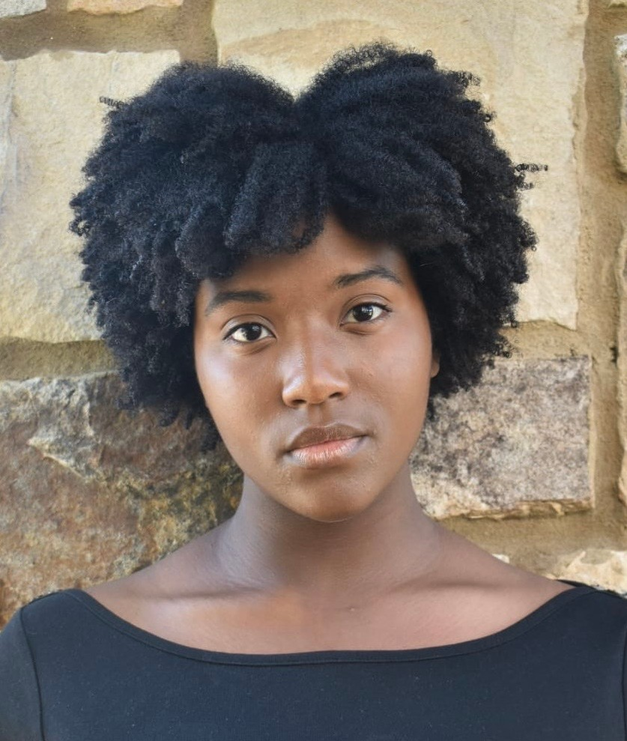
704-254-1054
zoelogan0506@gmail.com

www.zoerlogan.com
Bachelors of the Fine Arts: Performance (by 2027) Puppeting Workshop w/ Rick
Lyons
Beginner Ballet Beginner Modern
Intermediante Hip Hop
Color guard Clarinet
Reading Sheet Music Left Split
Back Bend
SKILLS
TRAINING
EDUCATION
CONTACT INFO
AWARDS
JO ANNE SMITH DANCE AWARD
Catawba College 2024
EXCELLENCE IN ACTING
North Caroline Theatre Conference 2023
OUTSTANDING PERFORMANCE IN THEATRE
Porter Ridge Highschool
2023

